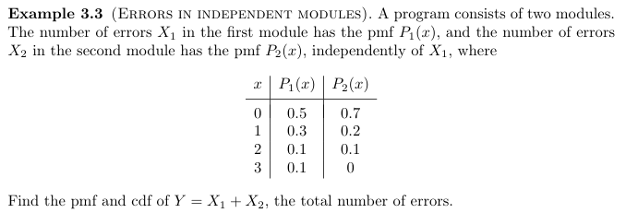
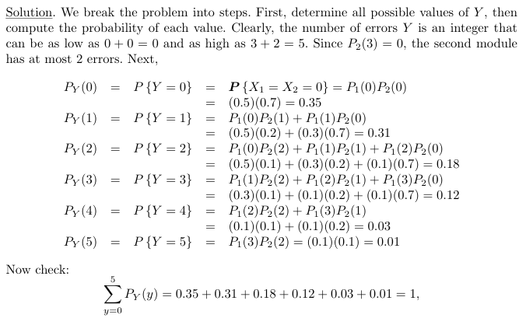
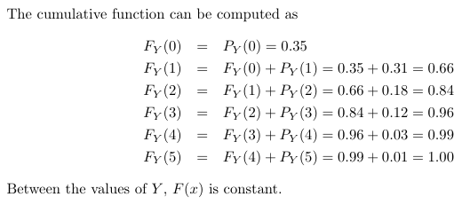
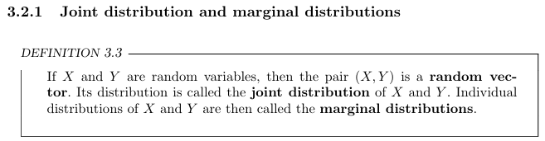
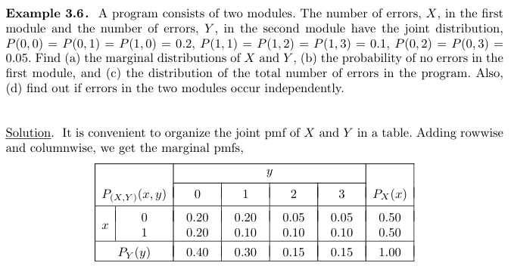

- the marginal distributions of X and Y,

(b) the probability of no errors in the first module,

PX (0) = 0.50.

(c) the distribution of the total number of errors in the program.
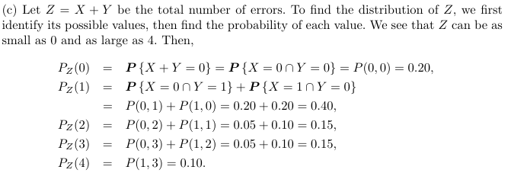
= P(0) + P(1) + P(2) + P(3) + P(4)

= 0.2+0.4+0.15+0.15+0.1 = 1

(d) find out if errors in the two modules occur independently.
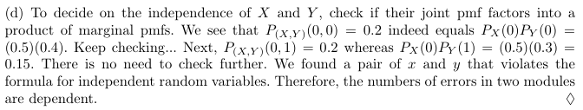

3.1. A computer virus is trying to corrupt two files. The first file will be corrupted with
probability 0.4. Independently of it, the second file will be corrupted with probability 0.3.
(a) Compute the probability mass function (pmf) of X, the number of corrupted files.
(b) Draw a graph of its cumulative distribution function (cdf).

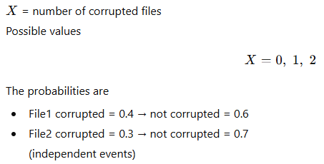
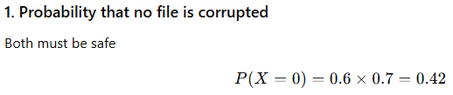
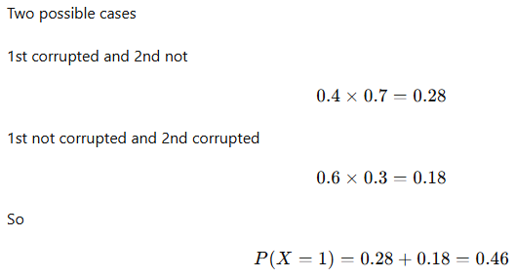
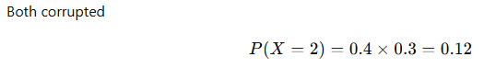
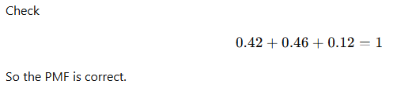

b) Cumulative Dist function F(x)

$F\left(X\right)= \left\{\begin{aligned}\begin{matrix}0 , x<0 \\ 0.42, 0≤x<1 \\ 0.88, 1≤x<2 \end{matrix} \\ 1, x≥2\end{aligned}\right.$

Graph of CDF
